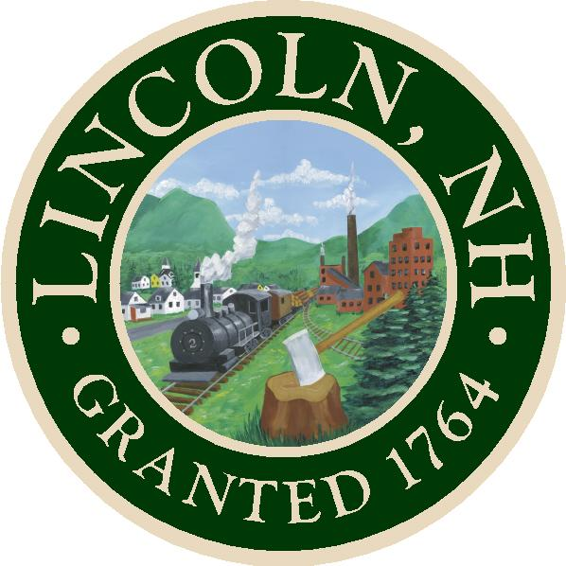 TOWN OF LINCOLN
Office of the Selectmen
148 Main Street – P.O. Box 25
Lincoln, New Hampshire 03251
O.J. Robinson Jack Daly Tamra Ham

Phone: (603)745-2757 - Fax: (603)745-6743 - Email: TownHall@LincolnNH.org

AGENDA

Lincoln Board of Selectmen’s Meeting
Monday, September 20, 2021
Lincoln Town Hall, 148 Main Street, Lincoln NH
5:30 PM
The Board of Selectmen’s Meetings will NO LONGER be livestreamed. The Town Hall Building is now open to the public, and the Selectmen’s meetings will be live, in-person participation.

- CALL TO ORDER at approximately 5:30pm
- REVIEW AND APPROVAL-MINUTES OF THE PREVIOUS MEETING
- REVIEW OF PREVIOUSLY SEALED NON-PUBLIC MEETING MINUTES
- NON-PUBLIC SESSION Pursuant to RSA 91-A: 3II(a,c,e,j) The BOS will be going into non-public session at 7:00pm for a personnel matter.
- ADJOURNMENT

Join Zoom Meeting
https://us02web.zoom.us/j/84398272681?pwd=Vi84UzBJbWxFRW5NdTBPYkh4U0txUT09
Meeting ID: 843 9827 2681
Passcode: 185080
Dial by your location
+1 929 205 6099 US (New York)
Find your local number: https://us02web.zoom.us/u/kcSuQgv0ec

