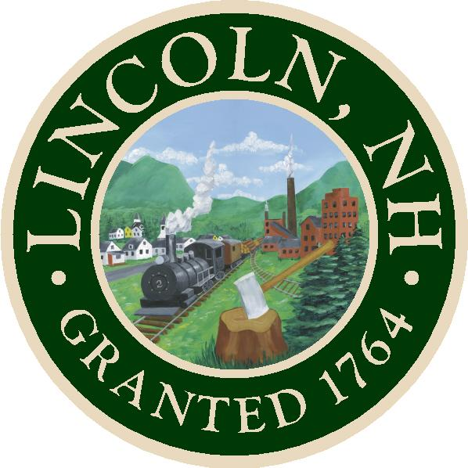 TOWN OF LINCOLN
Office of the Selectmen
148 Main Street – P.O. Box 25
Lincoln, New Hampshire 03251
O.J. Robinson Jayne Ludwig Tamra Ham

Phone: (603)745-2757 - Fax: (603)745-6743 - Email: TownHall@LincolnNH.org

AGENDA

Lincoln Board of Selectmen’s Meeting
Monday, November 16, 2020
Lincoln Town Hall, 148 Main Street, Lincoln NH
5:00 PM
These meetings will NOT be livestreamed any longer. Due to the current COVID-19 situation, the Town Hall Building will be closed to the public until further notice. This meeting will also be available via the Zoom Meeting Platform to allow for town wide participation

- CALL TO ORDER at approximately 5:00 pm
- REVIEW AND APPROVAL- MINUTES OF THE PREVIOUS MEETING (11/02-11/9)
- OLD/NEW BUSINESS
- Town Manager’s Report
- Public Participation –

- NON-PUBLIC SESSION Pursuant to RSA 91-A: 3II(a,c,e,j)
- ADJOURNMENT
Join Zoom Meeting
https://us02web.zoom.us/j/89151438046?pwd=N0U4Yi8wWXpXUnpkNkFYalFsMzN1QT09
Meeting ID: : 891 5143 8046
Passcode: 595610
One tap mobile
+19292056099,,89151438046#,,,,,,0#,,595610# US (New York)
Dial by your location
+1 929 205 6099 US (New York)
Meeting ID: 89151438046
Passcode: 595610
Find your local number: https://us02web.zoom.us/u/kibpAICtc

